UNDERSTANDING FORMULA/ FUNCTIONS

Lesson Objectives:

- Identify a range
- Represent a range in spreadsheet
- Format values as currency
- Add decimal places
- Remove decimal places
- Develop formula determine the average of values in a range
- Distinguish between formula and function
- Outline the structure of a function
- Explore built-in functions

Spreadsheet software enables automatic calculation. Values can be calculated using formulas or functions.

ACTIVITY
Use the spreadsheet below to answer the following questions:

 | A | B | C | D | E
1 | Name | Science Score | Math Score | English  Score | Total | Average
2 | Simone | 89 | 88 | 76
3 | Andrae | 56 | 90 | 45
4 | Linile | 53 | 78 | 75
5 | Brenda | 35 | 56 | 90
6
7 | Highest Average
8 | Lowest Average
9 | Number of Students
10

- What is the range of the spread?

- Write the formula to calculate the total score for Simone.

- In which cell would the total score for Simone be stored?

- Having calculated the total score for Simone, how would you calculate the total score for the other students?

- Write the formula to calculate the average for Andrae.

- Imagine you wish add a range of values from D3 to D500? What would you use to calculate the sum of values within the range? Give reasons.

FUNCTIONS

Functions a built –in formulas. You need NOT to enter the individual cell addresses and the mathematical operator for 500 cells and so on, because you need to save time.

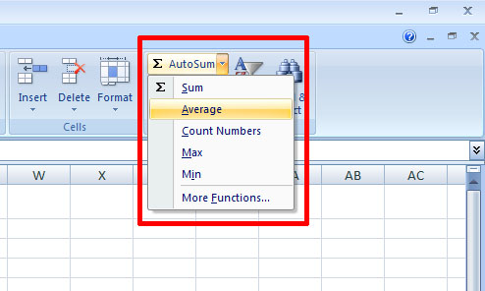

Use the spreadsheet below to answer the following questions:

 | A | B | C | D | E
1 | Name | Science Score | Math Score | English  Score | Total | Average
2 | Simone | 89 | 88 | 76
3 | Andrae | 56 | 90 | 45
4 | Linile | 53 | 78 | 75
5 | Brenda | 35 | 56 | 90
6
7 | Highest Average
8 | Lowest Average
9 | Number of Students
10

- Write the function to calculate the total score for Simone.

- In which cell would the total score for Simone be stored?

- Write the function to calculate the average for Andrae.

- Write the function to determine the highest average.

- Write the function to determine the lowest average.

- Write the function to determine the number of students in the class.

- Write the function to determine the number of Math Score.

RANGE
A range is a group of selected cells which can be next to one another (adjacent) or non-adjacent.
Ranges are identified by cell references e.g. A1:B6 or a name e.g. sales_table.

