INFORMATION TECHNOLOGY
DATABASE QUERIES

Use the database tables below to write the following queries

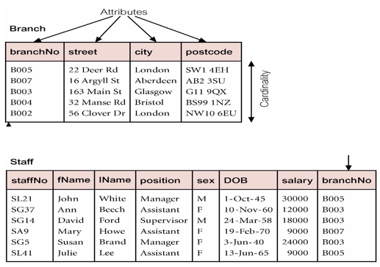
When filtering (querying) data from database, you need to
- identify the table to be manipulated
- select the required fields
- specify the condition or logical test

SELECT QUERY

- Create a SELECT query to list all the staffNo, firstname and sex of all staff whose salary is below 18,000. Place answer in the query design view table below

- How many records will be generated when the query is run? Identify these records? How many conditions are required? How many tables need to be manipulated?

- Create a SELECT query to list all the staffNo, firstname, lastname and position of all female staff whose salary is above 12,000.

- How many records will be generated when the query is run? Identify these records? How many conditions are required? How many tables need to be manipulated?

- list the staff name, salary and position of all staff who were born after 1950.

- list the staffno, salary and position of all the staff who works in London

CALCULATED FIELD QUERY:
This query enables to create and populate a new field that was not originally in your database.

Task: Each staff member is expected to return 1% of their Salary to National Housing Trust and 2% towards Education Tax.

Create a calculated field query to:

- show the actual amount of money paid by each staff towards NHT and Ed_Tax. Show the staffNo, firstname, lastname and salary of each staff.

TOTALS QUERY

Total Query
Create a query to determine the highest and total salary paid.

LET’S PRACTICE

- Download the EMPLOYEE database from class website.

- The teacher will demonstrate how to create the queries above using the Employee Database and you expected to follow and perform some on your own.

DATABASE REPORT
Create a report to show the Firstname, LastName, DOB, Sex, Position, Salary, BranchNo, and the City where each employee works. The information must be grouped by gender and the report must show a summary of the average salary and total salary by gender. Name the Report ‘Employee Report 2018’

HOW TO CREATE QUERIES

- Select CREATE
- Click QUERY DESIGN
- Add the tables you need to manipulate
- Double the fields you need to show
- Insert criteria
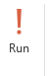
- Click RUN

- Save query using appropriate title

HOW TO FORMAT CURRENCY VALUES IN A FIELD

- Activate design view of the query
- Click on the value field you wish to format
- Click Property sheet
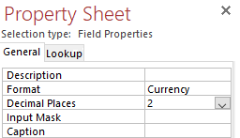

- Apply currency format and specify 2 decimal places

HOW TO CREATE A DATABASE REPORT

- Select CREATE

- Click Report Wizard
- Read and follow instructions carefully
- You may need to modify the report in design view if NOT all of the information is visible.

