Database Key & Database Queries Name: ____________________________
Use the correct term below to complete the definitions

Foreign key Primary Key Candidate Key Secondary Key

Composite key

- A _______________________ is a column, or set of columns, in a table that can uniquely identify any database record without referring to any other data.

- A _____________________ is a candidate key that was selected to uniquely identify a record

- A ____________________ were candidate keys that were not selected to be the primary key.

- A _______________________ is a column, or set of columns, in a table that are used to uniquely identify any database record without referring to any other data.

- A ____________________ is a field (or collection of fields) in one table that uniquely identifies a row of another table.

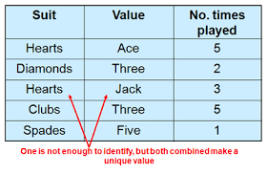
Table 1 illustrating candidate key.
Table 2illustration composite key
- How many candidate keys were in the table?
- Which candidate key became the primary key?
- How many secondary or alternate keys are in the table?
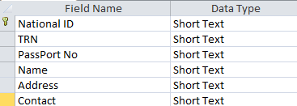

Use the following relationship report of Chen’s Database to answer the following questions
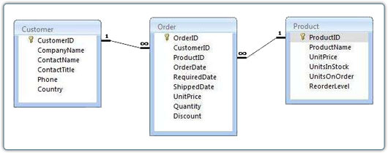

- Create a query to show the Customer ID, Name, Contact and Country of all customers.
- Create a query to show the Customer ID, OrderID, ProductID of all ORDERS completed on May 16, 2018. (Use data from three tables)
- Create a query to show the Product ID, Unit Price of all items below $600.00 that was shipped between January 1, 2018 and May 15, 2018.

- Create a query to calculate the cost paid by each customer before discount on each order. Name the field Cost. Show the OrderID, CustomerID, ProductID and date of order.
- Create a query to count the number of Shampoo in the stock

